History of my father, JAMES HYRUM HOLLEY, and my mother,
EMMA ISAAC, and children, as I can remember, and find records. Written by daughter Emma Teresa Holley Manwaring – 1954
*Notes added by Gregg Manwaring 2002
**Quotes and references submitted by Beth Hulet added June 2007

James Hyrum Holley was born in Warwickshire, England on 17th of November 1854. In 1856 the family, James Holley (father) and my father, James H. Holley, aged 2, a daughter Ann, aged 4, and the wife and mother, Lucy Jane Ingram Holley, sailed for America on the ship Enoch Train. They left Liverpool, England, on March 25, 1856 and landed at Boston, Massachusetts on May 1st, 1856. They were 38 days crossing the ocean.

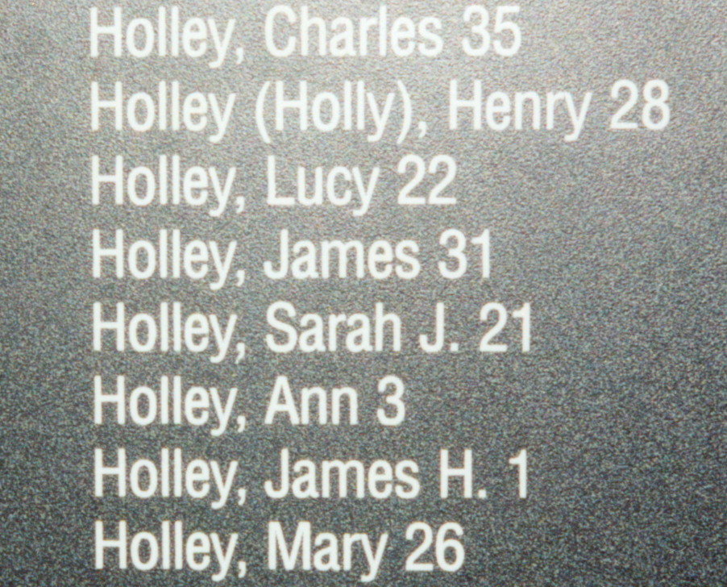
In the same company were 564 saints with Brother James Furgeson in charge. From Boston they traveled by rail to Iowa City, Iowa and then went on from there by wagon and handcart. *“In Iowa City they joined the John A. Hunt Wagon Company to cross the plains.*
*These Holley names are on
the wall at the Martin’s Cove Visitor Center

**“The Hunt and Hodgett wagon companies…were independent companies composed of church-owned wagons and of people who were financially able to buy their own wagons and teams. The wagon companies would leave Iowa City at about the same time as the Haven and Martin groups and travel closely with them for most of the
journey.” (The Haven and Martin groups would combine after
the journey across Iowa with historical records recognizing
them as one company – the Martin Handcart Company)
[pg. 230 “The Price We Paid”].**

**“The Goble family (great-grandparents of Marjorie Pay Hinckley, Majorie is the mother of President Gordon B. Hinckley) were among the Saints…who joined the Hunt wagon company, which traveled near the Martin company for most of the journey. 13-year-old Mary explained: “We had orders not to pass the handcart companies. We had to keep close to them to help them if we could.” [pg. 260 TPWP]**

**“The Hodgetts and Hunt wagon companies, which were assigned to travel closely with the handcarts, left Iowa City on July 30 and August 1. The Hunt company had 240 people, 50 wagons, 297 oxen and cows, and 7 horses and mules.” [pg. 274 TPWP]**

**Very soon they started across the great plains with wagons and handcarts. The ox teams were pulling the wagons, and divisions were made with about 10 wagons to a company.
Grandfather was made a Captain of one of the companies. This company suffered great privations, owing to bad weather and lack of enough wagons to carry what provisions and clothing they had. Here and there, they had to leave some of their things on the trail, other than the bare necessities. They were without bread at one time for four or five weeks, until relief trains came from Salt Lake. [Life Sketch of my Paternal Grandparents James Holley and Lucy Jane Holley by Emma Teresa Holley Manwaring]**

**“None of the handcart diaries mentions any interaction with the wagons while crossing Iowa, probably because the wagon companies were traveling even more slowly than the handcarts. The Hunt company journal shows that they struggled with their own share of difficulties and delays – straying cattle, capsized wagons, slippery roads, bad bridges, and a death.” [pg. 280 TPWP]**

**Winter set in as early as 20th of September. One night as they camped, a terrible storm came upon them, snow and sleet. They thought they would perish, and Grandfather stood by the wagon, and with uplifted hands, prayed to the Lord for deliverance, and rebuked the storm, and right away the storm ceased.

They suffered and traveled on. At Devil’s Gate they had to leave more of their possessions. This Company was the last handcart train to come into Salt Lake in the year of 1856, arriving about the 15th of December, 1856.” [Life Sketch of my Paternal Grandparents James Holley and Lucy Jane Holley by Emma Teresa Holley Manwaring]**

*They traveled close to the Willie and Martin Handcart companies, and were also caught in the early snows that winter, with many deaths in their company. Lucy Belinda, was born to them on the plains in October 1856. The half-starved and nearly frozen company came into the Salt Lake Valley on December 11, 1856, settling in Springville*.” (Bio from DUP on Lucy Jane Ingram)
They suffered many privations on this trip—were short of food and clothes, as they had to leave so much along the way.

On October 19,1856 a 3rd baby was born, a girl, but she died a few days after birth and was buried at the side of the road somewhere along the pioneer trail. *It was during the October general conference in Salt Lake City that Brigham Young organized a rescue party to go rescue the saints coming across Wyoming*. They finally arrived at Salt Lake City, Utah but only stayed there a few days. They went on to Springville, Utah arriving there December 22nd. I wonder if they felt thankful for that Christmas!

Here they made their permanent home. Children grew up suffering all the privations of that time. Grandfather and grandmother had a family of 12 children. Ann and Jim (my father) really had a hard life, being the oldest of the children. They worked together with the ox team, hauling wood and willows to burn. They had a sort of song they used to sing--"Gee up me boys, gee ho, as on road we go," etc.

About 1864, grandfather Holley homesteaded 160 acres of land in Hobble Creek Canyon, where Jim worked with his father a lot. Even though he was only 10 years old. They had a dugout to sleep in, and one night grandfather went to Springville, seven 7 miles away, and left Jim to stay alone for the night. Jim went to bed in the dugout with just a canvas hung at the doorway. He got nervous when he heard wolves howling and thought about bears and mountain lions that were around at that time. He got out of bed and walked to Springville, 7 miles, barefoot as he had no shoes. He didn’t have any shoes until he was 18 years old. He said he remembered his mother crying as he walked in the house. Grandfather was a hardhearted man, and was very overbearing and strict with his children. Dear grandmother was just the other way--kindhearted and full of tenderness for everyone. Grandfather did quite a lot of freighting in those days. When Jim was 13 years old he took a team and wagon along with his father freighting.

In 1863 he took a job with the firm of A.H. Eddy & J.S. Harvey of Chicago, Illinois. A traveling salesman at that time was called a “Drummer”. He traveled all over to the business places in those parts in a light wagon with a span of mules. At this job he worked for 17 years and made good money for those days. Jim (my father) said anytime grandfather came home, no matter what time of night it was, he would stop in front of the gate and whistle--this meant for Jim to get out of bed and take the mules to the barn and put them up for the night. The older children always spoke of the hard whippings they received from their father over mere trifles, it seemed.

As years passed Jim worked and saved $400 and when he was 26 years old he married Emma Isaac of Spanish Fork, Utah who worked as a telegraph operator for 9 years. She was 24 years old. They were married in the Endowment House Salt Lake City, Utah by Daniel H. Wells on October 9, 1882. They lived in Springville, Utah for 8 years where 5 children were born to them: James, Russell, Richard Ferris, Emma Teresa, Mildren (died) and Dallas. I can still remember a school teacher, Larse Eggersen who lived with us at this time. He would take me on his knee and teach me songs. One verse I can still remember “Work while you work and play while you play. This is the way to be happy and gay.”

In March 1890, we moved to Mapleton, Utah, 2 1/2 miles east of Springville. Father bought a farm of 20 acres. Just a few families lived there at that time. Mother felt like we were out in the wilds, but felt that was to be our “real” home and we were really satisfied. The land was very fertile but needed leveling, ditches made, fences built. Sheds and buildings for the animals were planned for and built in due time. Father had years of work ahead of him. Mother did also, as the house we had was part brick and two room’s frame. It had been used as a schoolhouse--had high windows and birds had their nests all through the attic. The house was also infected with bed bugs, which took 4 or 5 years to get rid of. We used gallons of coal oil and fumigated with everything we knew of and could get at that time.

The following July 29th, we had a new sister born to us - Hatsie. She was followed by 3 boys during the next 4 years. November 13, 1892, Ben was born. March 2, 1894, John Isaac was born and 10 August 1895, Glenn was born. Mother's babies were born close together and all of them were raised on the bottle. In 1897 another baby not was born but he only lived 3 days. He was named Donald. Now our father’s family consisted of 6 boys and 2 girls. Father always planned work for everyone. We girls never had to do work outside unless we wanted to. Mother never was very strong and many times the boys had to come in and help in the house. We papered and painted the whole house and mother always made cushions, rag rugs and carpets so our home always looked clean and homey. We had an old organ, which used to belong to grandfather Isaac. It was the 3rd organ brought to Spanish Fork, Utah. It served us well for years. We all learned to sing while mother played.

As the town grew father was always helping. He was made Roadmaster and for many years worked for wider roads and good fences and ditches and more bridges. He first moved his own fence back a rod and expected everyone else to do the same. Everyone had to pay a poll tax so dad got them all to work out their poll tax by hauling gravel and working on bridges, etc. It seemed he was always building up the town.

Dad was a very good farmer, always leveling his land and improving everything in general. He kept acquiring cattle, lovely horses and good machinery and was always very generous on loaning machinery to his neighbors. About 1894 in the summer in a far corner of our field, dad found a clump of wheat with 5 heads and kernels about 3 times larger than ordinary wheat. He protected this wheat and when it ripened he gathered the heads and put them in a glass jar on the top shelf of mother’s dish cupboard. Next spring he planted one half acre and it was so wonderful. The next year he planted his whole wheat land with it. Then he exchanged it with his neighbors. They were glad to pay 1 ½ bushels of wheat for one bushel of dad’s wheat. It was called “Holley’s Wheat” for years. Dick Lowe, a friend of dad’s of Springville, Utah, moved to Burley, Idaho and took some of this wheat of dad’s with him. There it became known as the “Dick Lowe Wheat” or “Dick’s Wheat”. I always think of it as being the same strain of wheat which my father found in the corner of his farm. One of those things that “just happened”!

About 1896, we had quite a hard time, for almost a year, short of irrigation water and weevil in the sugar beets, all crops being short and scarce. Grover Cleveland was president at this time and all republicans blamed hard times on him as he was a democrat, however, we kids were told that old Santa was poor also—that he wouldn’t be around that Christmas, but we kids were sure he would come as he had always before. We all hung up our stockings and not a thing was in them. We were all disappointed but I don’t think anyone cried except mother. Dad said that he had heard that old Santa would make it up the next year. It happened as he said--the next Christmas our stockings were filled with everything nice and when we went to put our shoes on, they were full of candy and nuts and so we all felt repaid.

Father worked in the M.I.A. and Sunday school for a few years. He was Sunday school superintendent for several years. He had a tactful way of getting along with people--especially with boys. Many men have said how he had helped them back on the right road many times when they were young and foolish.

About 1894 Father had a call to go on a mission. My oldest brother was only 10 years old. Mother was not very strong so father wrote to the President of the Church explaining the conditions to him. He received a nice letter telling him to look after his family, as they were his first responsibility.

As our 6 boys grew up, dad always planned work for them all and encouraged them by giving them a calf or a colt, pigs or something. They were all the more interested in working at home. As they planned their work each day, the boys were given teams to drive; machinery to run and father would take the jobs the boys didn't want to do whenever he could. Each boy was let go to do what he liked--they learned to run mowers and rakes and all other kinds of machinery when they were really young. Mother always worried for fear they would get hurt.

We, as a family, had few bad accidents and sicknesses. Ferris broke his collarbone while staking, Ben broke his arm by falling off a mowing machine, Dallas broke his arm at the elbow and it is still crooked. When Glenn was about 2 years old, he got a table fork tine stuck in his eye, which caused the loss of sight in the one eye. Dallas took typhoid fever one summer when he was about 16 years of age. He was really sick! He got down so poorly that he was just skin and bones. I took care of him, as mother was not well. I went by the doctor's orders. Used to have to sponge him off about every 20 minutes during the day. His poor legs were so thin that I would shed tears every time I did this. I'm sure it was our prayers and the prayers of the elders that saved his life. The doctor told me I was sure a good nurse. When the fever left and Dallas could have something to eat, he would just cry as he was so hungry and all he could have at a time was a spoonful of rice, cooked 1-1/2 hours, or a very small piece of broiled beef. This, of course, only lasted a few days and then he could have more. Then my brother John took the same disease but was not very bad and soon got over it.

One time I remember when they were unloading hay in the summer, Dad was on the stack and one of the boys running the Jackson Fork. The rope slipped out of his hand and let the fork down. It came down on dad's head. One point of it jammed in his head and made quite a hole in it. We were pulling straw out of his head (in the sore) for a long time. It took a long time to heal. The fork had pushed through his straw hat and carried them into his head. It eventually healed up good.

In Mapleton we were very fortunate to have Aaron Johnson’s family who were very dramatic. They used to stage a lot of plays with home talent. This proved to be real fun for our ward. Our dad was also one of his good actors and also my brother Russell. They even did some of Shakespearean plays. Mother always played the organ and Henry Curtis the violin. That was the music we all danced to.

I remember our church house there--so plain, with wood floors all bare. Curtains were pulled when we went to class. Sacrament water was sipped by everyone from the same glass and passed along. Fast meetings were not held on the Sabbath day. Testimonies were borne and babies blessed on Thursdays. Now our churches are clean, spacious, peaceful and sedate. Large windows beautifully draped. Drama and dances are held. There is room for every class and a place to play ball--what more can we ask? The sacrament trays--chrome and shiny bright with individual cups--everything is just right. How thankful people like us should be to have and to enjoy all these improvements we see. May we ever be loyal and steadfast as the sod, and acknowledge the stream of blessings coming from God.

In 1902 grandfather Holley passed away and my father bought the old Holley farm in Hobble Creek Canyon from the estate--making added work for us all. During hay time I cooked for the boys while they put up the hay.

In 1903 our oldest brother, Russell, left (when 19 years old) for a mission on the 7th of January to Albany, New York. He labored in Albany most of his mission. At this time he heard a lot of talk and stories about Senator Smoot which were not true. Elders laboring in that district were T.G. Richardson, G.W. Bruce, J.P. Herrick and James Russell Holley. Elder B.H. Bitner had been released and sent home. At our home we had a large fruit orchard, all kinds, and mother and us girls and smallest boys did most of the fruit picking and marketing and the money was sent to Russell for his mission expenses.

After he returned in 1904, he married his old sweetheart, but things didn't work out and they separated. Russell went to California and married Uda Gibson. They have their home there and 3 children. He worked in a shoe store until he retired. Now he and his wife have a real estate business.

My boy friend was called to England on a mission in 1907. We decided to get married before he went. We were married October 23, 1907 and 6 days later he sailed for England. I worked in a store as sales lady while he was gone. He returned home the day before Christmas in 1909 and there was a happy Christmas time. We went to Bingham Canyon and worked for about 3 months, then the 1st of April we came to Blackfoot and ran a farm at Groveland with his brothers. I didn't get back home for a visit for several years. The boys grew up and married and I didn't get to know their wives for many years. They were scattered from California to Canada.

My father “Jim” Holley never did get up to Idaho. He was always “too busy”. He would have loved it here with all of this land and water--canals and rivers. My mother Emma came up once when my oldest child Marie was about 6 months old and some more later on.

My father lived until 1918 and my mother until 1934. She was very crippled up with rheumatism for many years.

Now if any of the James Holley sons or daughters think of anything interesting about our home life together, write it on the bottom of this sheet so it will be on the record.

/s/ Emma Teresa Holley Manwaring

Notes add by Glenn Holley…

My father, Jim Holley, was one of the kindest, friendliest men you could ever imagine. Grandma Emma used to say that Jim would invite anyone to his home for a bite to eat.

We had family prayer every morning without fail. Afterwards we would sit around and Dad would ask the boys what they would like to do on that day. Glenn ahd to milk the cows most of the time, even though his hads were so small he could barely reach around the teats. Glenn said he became very professional at milking.

A ditch used to run near their home. We finally were able to have a well–one of the first in our neighborhood. It was about 56 feet deep, and the water was cold and delicious. My dad was always up at 4:00 a.m. He called his wife, “Ma.” They both took some bright, pink pills for pain. One night Dad got up in the dark and got some liniment and rubbed it on his hips and back. Then he crawled back into bed, but got out again, and turned on the light. He had rubbed himself with sticky cough syrup.

Beds were made of straw ticks, and sometimes Dad and Mother were nervous about burglars. One night Dad tied a rope to the bed and to the door knob, but then they realized that the door opened in, and the rope did no good for protection!

When Harold came to live with Dad and Mom, he was about 4 years old. He was bit afraid of Grandpa Jim. He used to call Dad “Hiddly Diddly.” Grandpa Jim didn’t like that much and used to hold Harold by the suspenders and shake him, but Mom always took Harold’s part.

Mom was always afraid to pray in meetings. She had a very good friend by the name of Sister Jolley. They made a pact that when they called on Sister Holley to pray, that Sister Jolley would stand and pray. They always sat together.

Mom had an old organ she played often. Each night before the kids would go to sleep, she would have to paly the song, “Over the Waves” as they would wait for the song before settling down.

I don’t think my Grandfather Holley was a very kind man. One time my father went to him and asked if he would give him one sack of flour, but Grandpa Holley wouldn’t give his son any flour for his family. One Christmastime when my parents didn’t have much money, Dad’s brother, John, brought a Christmas tree and some presents. They trimmed the tree and put it up after all the children had gone to bed.

We always had a tent pitched on the lawn where the boys slept in the summer. The house was small and not enough bedrooms for this big family.

Mom was a hard working woman, but had rheumatism in her legs, and there wasn’t any medicine to take or any ointment to rub on rheumatic aches to relieve it.

These are some musings on this 19th day of May 1980, which come to my memory.

/s/ Glenn Holley

